Caravan and Motorhome Club
East Kent Centre



Guide to Marshals

Version No: 3.4

Change Notes

Version No | Description of Change | Date
3.1 | New Pitch Sizes and Accounts sheets added | 19/5/2014
3.2 | Layout improvements introduced using styles, minor  grammatical changes made. | 20/5/2014
3.3 | 2020 update | 15/10/2020
3.4 | 2021 update | 21/10/2021

The Committee would like to thank all the rally marshals for running rallies. It is hard, but extremely rewarding work and the Centre would not be able to put on such a wide and varied rally programme without the continued support of our marshals.

This booklet is intended to act as a guide and a reminder and also to keep you up to date with rally rules and regulations.

Contents

1. | The Rally Field and Initial Paperwork | Page 4
2 | Rally Equipment | Page 4 to 5
3 | The Rally | Page 5 to 8
4 | Who Can Attend EKC Rallies | Page 9
5 | At the Site | Page 9 to 10
6 | Rally Paperwork | Page 10
7 | A Guide to the completion of Rally Paperwork | Page 10 to 15
8 | Rally Route Signage | Page 15
9 | Personal Accident Insurance | Page 15

THE RALLY FIELD AND INITIAL PAPERWORK
  - The Rally Secretary will negotiate the site fee with the landowner and will let you have any relevant correspondence regarding your rally. This will have the costs and any restrictions that the landowner may have made. The Rally Secretary will have checked the site for capacity, drinking water and waste disposal. They will also provide you with an Account Summary sheet, Attendees List, 1st rally form, Equipment Application Forms, any other relevant forms. These sheets are also available on the EKC website.
  - Complete the Marshal Information form (with details of the rally, assistant marshals, contact details, etc.) and return it to the Rally Secretary within one month so information can be added to rally book. When setting the time that the rally opens, allow yourself time to set up, mark out the site and position the EKC road signs.
  - Visit the site about six weeks before the rally and meet the landowner.
    - Confirm timings, access, siting, out of bounds areas, etc.
    - Check the water supply and waste/Elsan disposal arrangements.
    - Ask the landowner whether other users will occupy the site during the duration of the rally (e.g. football clubs on school fields) and make arrangements to ‘mark off’ the rally field if necessary.
  - If there are any changes or additions from those advised by the Rally Secretary, get them confirmed in writing in case of problems later. If, after visiting the site, you believe that it has become unsuitable, contact the Rally Secretary immediately.

RALLY EQUIPMENT
  - Complete the Equipment Application form (which will be sent to you with this booklet) and send one copy to the Equipment Officer at least 14 days prior to the rally. You will need to arrange how and when the equipment will be collected. It is down to the marshals to pick up and return equipment.
After the rally, give the second copy of this form to the Equipment Officer. If you have passed any of the equipment to the next or a future rally marshal, then please complete the form which is with the equipment application form.
  - The Chairman/Chairlady and Vice Chairman/Chairlady carry centre Flags and PA Systems. If neither are booked into your rally, please make sure you have the Centre flag, as this is our insurance.
  - The defibrillator is held by the Chairman/Chairlady. If the Chairman/Chairlady is not at the rally then a member of the committee will be responsible for the defibrillator. If no committee members are attending the rally, then the Marshal will need to collect and return the defibrillator from the Chairman/Chairlady and will be responsible for the duration of the rally.

THE RALLY
  - Plaques are ordered for each rally and the Rally Secretary has a book of designs which they will either email to you or let you see whilst at a rally. Choose the motif/colour and wording for the plaque using the order form which will be given to you by the Rally Secretary. Liaise with the Rally Secretary on quantity required so that the plaques can be ordered. The plaques will be sent directly to your home address. If your rally is a ‘large plaque rally’ (i.e. a special event – Valentines, Easter, Birthday, Bonfire, Holiday Rally, Harvest Supper, Christmas or New Year) choose the design at least four weeks before the rally. If it is only a two-night rally your plaque will be a triangle.
  - If you have room, late or non-bookers may be accepted. They will not be entitled to a plaque unless you have a spare or to papers if they are delivered or pre-ordered. The Chairman/Chairlady has a supply of ‘I booked late’ plaques. Return surplus plaques to the Rally Secretary to keep as spares.
  - If the rally is not well supported, the marshal cannot call off the rally or cancel a social. They should contact the Rally Secretary who will in turn notify the Centre Chairman/Chairlady.
  - The social programme must stand on its own financially. The cost of the hall, food, entertainment, cost of transporting party tents, VAT, etc. must be costed into the social fee.
For Social tickets a child is over 4 and under 18, except for catered socials where there may be a charge for younger children. The charge for under 4’s must be advertised before the rally.
Important. Please note that the Caravan & Motorhome Clubs liability insurance only covers socials that are accounted for through the centre’s books and where VAT is paid. Socials that are not accounted for in the centre’s books are treated as private functions and are therefore not covered and your own insurance should be obtained.
  - No socials are to be arranged without being published in the Rally Book, except impromptu events that may be held as long as the charge does not exceed £2.00 (including VAT) per person. This will usually restrict such an event to a non-hall social or an extra social where the hall has already been paid for.
  - If you wish to do papers then arrange for the collection (delivery) of papers. Ralliers should pay for their papers at the rally. Do not add paper money to their fixture/social fees.
  - Known additional costs for rallies (e.g. Travel expenses to pick up party tents) should be factored into the rally social price. These costs can be a reason why a rally can make a loss.
  - Cancellations – if you receive any information regarding the reason for non- attendance, please note this at the bottom of the summary sheet. This will assist the Treasurer when deciding whether a refund is to be made.
  - Copies of the following documents will be displayed on the notice board and are also held by all committee members and carried with the centre flagpole and flag.
- Caravan & Motorhome Club Exemption certificate
- Caravan & Motorhome Club Liability Insurance
  - If the Marshal has been granted an extension to the social closing time, it is to be publicised in the rally letter.

PITCH SIZINGS
On page 7 & 8 are the pitch sizes the centre will use. The Diagrams have been simplified to assist the Marshals.
Page 7 is for Hard Standing sites.
Page 8 is for Grass sites.
These sizes are slightly larger than the recommended sizes by the Caravan & Motorhome Club this is to allow for units to be sited at an angle if required to do so.
If the Marshal has any questions, please contact the Rally Secretary.

Hardstanding Layout Nose to Nose

Marker Peg
9 Metres
6 Metres
6 Metres
9 Metres
6 Metres

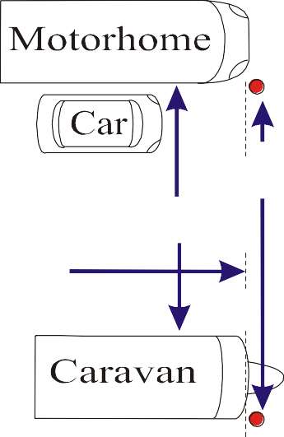Hardstanding Layout Nose to Tail

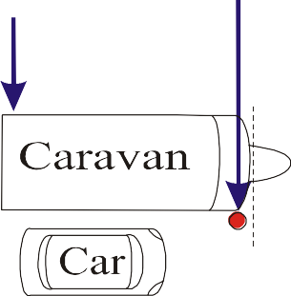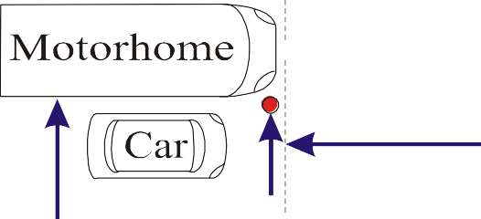15 Metres
6 Metres
9 Metres
9 Metres
6 Metres

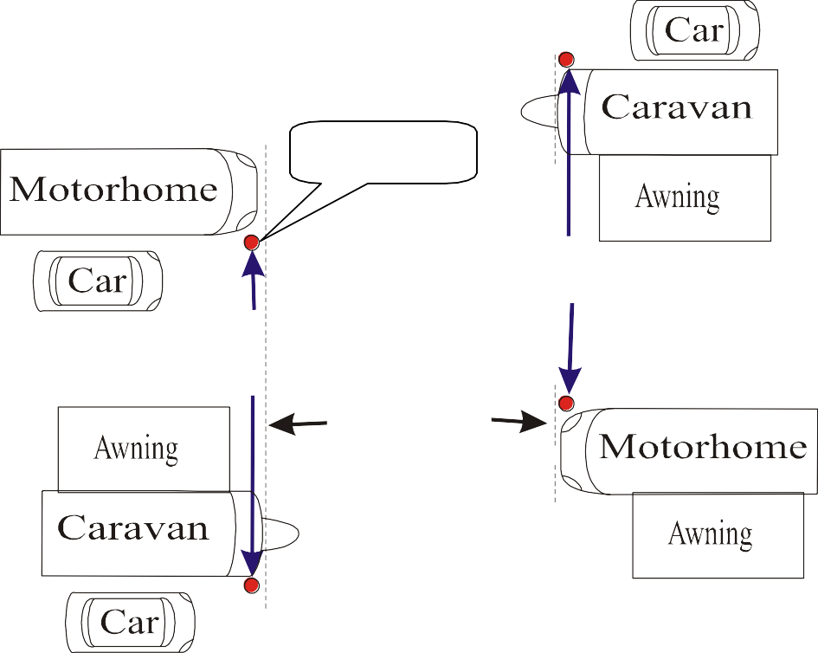
Grass Layout Nose to Nose
Marker Peg
12 Metres
12 Metres
6 Metres

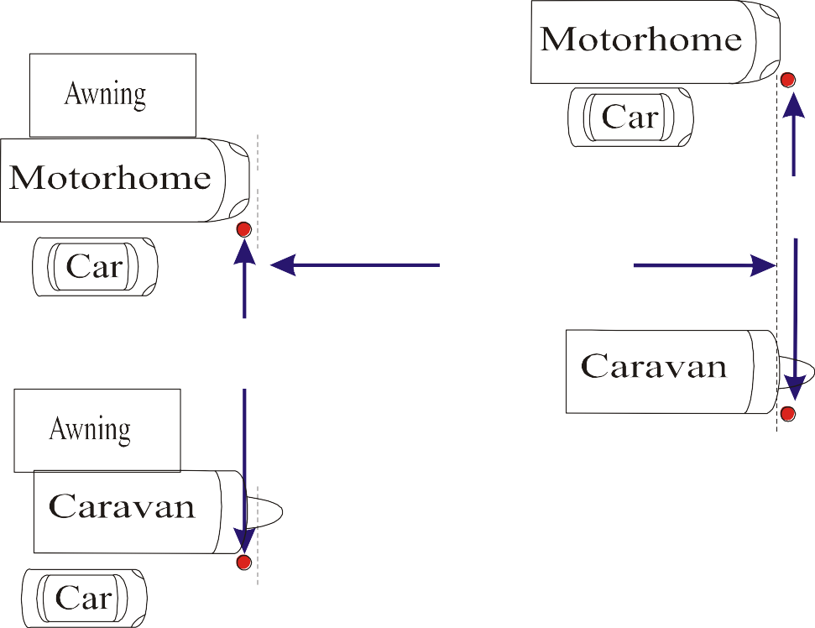Grass Layout Nose to Tail

12 Metres
15 Metres

12 Metres

WHO CAN ATTEND EKC RALLIES?
  - Under the terms of the Exemption Certificate issued to the Club, only Club Members can attend rallies with their caravans. The practice of allowing non- members to attend a rally on a trial basis is no longer allowed. This does not stop visitors staying in a member’s caravan providing the member IS PRESENT. If in doubt as to whether a rallier is a member of the Club, you can ask to see his/her membership card.
  - Rule 4(a) of the Rules Governing Centres states that:
“All events organised by a Centre shall be open to any member of the Club, subject to accommodation being available. All members shall apply in advance.”
This means that you cannot exclude someone, unless there is a valid reason advised by the committee.
  - All rally fees and booking slips to be given/sent to marshal at the time of booking. Cheques should be made payable to ‘The Caravan Club East Kent Centre. ‘NO FEES NO BOOKING’. Payment by BACS is now available. The member should contact the Marshal for the bank details which will be given to the Marshal by the Rally Secretary.
  - If you have a first time rallier please take time to phone them and acknowledge their booking and explain what happens when you book into a rally as they won’t know that they don’t get a reply when their booking arrives on the Marshal’s mat. Thank you.

AT THE SITE
  - HEALTH AND SAFETY – We have a duty of ‘Health and Care’ towards all persons on the Rally Field. The Marshals must complete an inspection of the site and assess the risk of possible injury. Any hazards identified are to be brought to everyone’s attention and, if possible, marked or cordoned off.
  - A risk assessment will be prepared by the Rally Secretary and sent to the Marshal for approval. Once approved the Rally Secretary will forward the risk assessment to the landowner. If any further risks are ascertained whilst on preliminary visits or whilst on site at the rally then the Rally Secretary needs to be notified immediately in order to update the risk assessment accordingly.
  - The Marshal decides the siting of the vans but must comply with the Pitch Spacing diagram. (Allow more space if the area permits). Vans should normally be sited with the offside front corner over the peg. The Rally Secretary will ensure that marshals and their assistants are registered with East Grinstead. Should the main marshal need to leave the rally early or is no longer available, a new main marshal should be identified. The new marshal should telephone 01342 336707 and leave their details on the East Grinstead answer phone and also notify the Rally Secretary.
  - The movement of cars on wet grass must be kept to a minimum and should be stopped completely in very wet conditions. As the person in charge of the Rally it is your responsibility and the Committee will uphold the decision you make. If you deem that the field is either too dangerous to drive on or there is a danger of the field being severely damaged by excessive movement, notify the Chairman/Chairlady/Vice Chairman/Chairlady who will then raise a yellow flag below the centre flag. This means that there is to be no unnecessary vehicle movement and if vehicles do have to leave the rally field, advise the driver that there is a possibility they will not be allowed back on and will have to park offsite.
  - Visitor’s cars and second cars must not be parked next to a caravan/motorhome but sited in a separate area.
  - Check that the notice board information is up to date. Add a list of known attendees in alphabetical order – add if they are Centre Officers/Committee members or a Past Chairman/Chairlady. First Ralliers and visitors from another Centre or non-Centre visitors should also be identified and listed first. Give a copy to each Committee member present.
  - If a caretaker is involved, keep him/her informed of your intentions and activities. A gratuity of £10 may be paid in appropriate circumstances (this can only be authorized by a Centre Officer).
  - The Flag and Flagpole will be carried out by the Chairman/Chairlady or Vice Chairperson and will not be your responsibility.
  - Private generators may be used, but are not to be used excessively, which may cause annoyance to other ralliers; if possible, generators should be positioned away from caravans to lessen the noise. They are not to be used between 9pm and 9am.
  - It is recommended that Marshals site their caravans at or near the entrance to the site so they can welcome ralliers and monitor access to the site.
  - Make sure that the site is left at least as clean as it was when you arrived.

RALLY PAPERWORK
  - Give the Rally Secretary a list of actual attendees, in alphabetical order, with initials, car registration and caravan, and centre to aid identification for his/her register of names in the ‘Colours’ records.
  - An attendance list is to be given to the Chairman/Chairlady and other committee members at the beginning of the rally.
  - Let the Rally Secretary have the names and addresses/telephone numbers, if known, of any suppliers or contacts that you have made, or any other information that may assist and benefit a future marshal.
  - Ensure that the booking slips have been completed in full.
  - Send the completed Rally Finance Listing and Summary Sheets, together with the booking slips, cheques, cash and any receipts, to the Treasurer. Please ensure that the rally slip(s) from any member(s) who cancel their rally are included with the paperwork and sent to the Treasurer. If you can’t get the accounts to the Treasurer, please give to any other committee member who will pass them on.

GUIDE TO THE COMPLETION OF RALLY PAPERWORK
  - Because we are part of the Caravan & Motorhome Club, we come under the Club’s VAT number.
- All income received for a rally is subject to VAT. (VAT is already included in the rally fee, which is calculated by the Rally Secretary.)
- Income received for a social is also subject to VAT. When calculating your social fee, you must deduct VAT from the total to find out how much you can actually spend. If the social fee were (£4.00 then the VAT content would be 80p at 20% and would mean that you have £3.20 to spend). This is an example it depends what the VAT rate is at time of rally.
- VAT can be claimed back on certain social expenditure where a VAT receipt is provided. VAT cannot be claimed back on food purchases. When purchasing items for your rally do not include your own personal shopping on the same receipt. The Treasurer will be able to claim back any VAT on a rally receipt.
- If you are using a hall or other premises for the social, your social charge must cover the cost of this and any food you are supplying or entertainment you have to pay for. The Rally Secretary will tell you the VAT status of the premises and if it is Vatable, you will need to add in the VAT to calculate your social charge.
- Some schools are now charging a fixed fee for the weekend, which includes the use of the hall. If this applies to a rally you are running, ask the Treasurer how much of this fee is going to be allocated to the hall and include this in your social cost.
  - Marshals are not responsible for paying for any premises used. The Treasurer will do this.
  - You will receive the Fixture Marshal Account Summary and payment sheets from the Rally Secretary. These can also be found as Excel spreadsheets on the EKC website under Marshals Accounts. If you use the spreadsheet from the EKC website, look at the bottom of the page. There are three “headings”. Summary Income, Summary Expenditure and Sheets 1-4.
  - The first sheets to fill in are the payment sheets. If you are able to fill these sheets in on a computer it will add up the columns for you. If you are filling the sheets in by hand, you will need to add these columns yourself. This sheet enables you to check the cash & cheque amounts that you actually have. (If the rallier hasn’t written the method of payment on their rally slip, it would be helpful if you could do this.) IE: - BACS/Cash/Cheque/Voucher
Venue: Oasis East, Sheppey | Fixture No: 1862 |  |  | Dates: 29.12.21 - 2.1.22 |  |  | Marshal: P & P Burgin |  |  |  |  | Sheet: 1
 | Fixture | Social |  | Social |  | Social |  |  | Total Amount Paid
Name | Fee | No. | Amount | No. | Amount | No. | Amount | BACS | Cheque | Cash | Voucher | (Refund)
Mr & Mrs Smith | 45.00 |  | 30.00 |  |  |  |  |  | 35.00 |  | 40.00
Mr & Mrs Robinson | 45.00 |  | 30.00 |  |  |  |  |  | 75.00
Mr & Mrs Allen | 45.00 |  | 30.00 |  |  |  |  |  | 75.00
Mr & Mrs Davey | 45.00 |  | 30.00 |  |  |  |  |  |  | 75.00
Mr & Mrs Simpson | 45.00 |  | 30.00 |  |  |  |  |  | 75.00
Mr & Mrs Archer | 45.00 |  | 30.00 |  |  |  |  | 75.00
Sheet 1 Totals | 270.00 | 0 | 180.00 | 0 | 0.00 | 0 | 0.00 | 75.00 | 260.00 | 75.00 | 40.00 | 0.00
(If necessary C/F to Sheet 2) | 450.00 |  |  |  |  | Grand Total |  |  | 450.00
Please indicate if a rallier cancelled or did not stay the number of nights paid for.

If someone overpays by cheque, you can refund the overpayment from the cash that you have and show it as a minus in the refund column
If you are given a cheque for the wrong amount and it is less than it should be, the rallier can pay the difference in cash. Their entry would then show and cheque and cash amount
Enter Rally Fee and Social Fee in the appropriate columns

Venue: Oasis East, Sheppey | Fixture No: 1862 |  |  | Dates: 29.12.21 - 2.1.22 |  |  | Marshal: P & P Burgin |  |  |  |  | Sheet: 1
 | Fixture | Social |  | Social |  | Social |  |  | Total Amount Paid
Name | Fee | No. | Amount | No. | Amount | No. | Amount | BACS | Cheque | Cash | Voucher | (Refund)
Mr & Mrs Smith | 45.00 |  | 30.00 |  |  |  |  |  | 35.00 |  | 40.00
Mr & Mrs Robinson | 45.00 |  | 30.00 |  |  |  |  |  | 75.00
Mr & Mrs Allen | 45.00 |  | 30.00 |  |  |  |  |  | 70.00 | 10.00
Mr & Mrs Davey | 45.00 |  | 30.00 |  |  |  |  |  |  | 75.00
Mr & Mrs Simpson | 45.00 |  | 30.00 |  |  |  |  |  | 76.00 |  |  | -1.00
Mr & Mrs Archer | 45.00 |  | 30.00 |  |  |  |  | 75.00
Sheet 1 Totals | 270.00 | 0 | 180.00 | 0 | 0.00 | 0 | 0.00 | 75.00 | 251.00 | 85.00 | 40.00 | -1.00
(If necessary C/F to Sheet 2) | 450.00 |  |  |  |  | Grand Total |  |  | 450.00
Please indicate if a rallier cancelled or did not stay the number of nights paid for.
There is a column to show payments made by voucher

  - The next sheets to fill in are the summary sheets. Again, if you are able to fill this in on a computer, the calculations will be made for you once the relevant numbers and prices are entered.

FIXTURE MARSHAL'S ACCOUNT SUMMARY
INCOME |  |  |  |  |  | EXPENDITURE
No. Nights | No. Vans | Fixture Fee |  |  |  | All receipts to be enclosed
1 |  |  | = | 0.00 |  | SITE FEES (CASH)
2 |  |  | = | 0.00 |  | SOCIAL EXPENSES
3 |  |  | = | 0.00 |  | TRAVEL
4 |  |  | = |  |  | PRIZES
5 |  |  | = | 0.00 |  | CARETAKER
FIXTURE FEES TOTAL |  |  |  |  |  | PHONE CALLS
SOCIALS:- | Number | Social Fee |  |  |  | OTHER EXPENSES
 |  |  | = |  |  | DETAILS:- |  |  |  | Disco
 |  |  |  |  |  | DETAILS:- |  |  |  | Food/Drinks
 |  |  | = | 0.00
 |  |  |  |  |  | MARSHAL'S ADVANCE
 |  |  | = | 0.00 |  | DETAILS:-
 |  |  |  |  |  | DETAILS:-
SOCIALS TOTAL
 |  |  |  |  |  | EXPENDITURE TOTAL
OTHER INCOME |  |  |  | 0.00
DETAILS:- |  |  |  |  |  | CHEQUES TO TREASURER
MARSHAL'S ADVANCE |  |  |  | 0.00 |  | CASH TO TREASURER
(Cheque)
MARSHAL'S ADVANCE |  |  |  | 0.00 |  | BACS TRANSFERS
(Cash)
 |  |  |  |  |  | VOUCHERS TO TREASURER
OVERALL TOTAL |  |  |  |  |  | OVERALL TOTAL
Please ensure that the income and expenditure totals agree.
MARSHAL'S COMMENTS
SIGNED |  |  |  |  |  | DATE

  - If you are still unsure of how to deal with any aspects of rally finance/paperwork, please contact the Treasurer - before the rally if possible. If you have any queries after the rally, please ask. It is much easier to deal with issues at the time rather than a week or two later when the Treasurer receives the paperwork.

RALLY ROUTE SIGNAGE
The following is an extract from a letter sent to all Centres by J A Bell, Executive Secretary of the Caravan & Motorhome Club, on 11 November 1997.
“We are able to erect such signs under a concession available in Section 5(1) of the Local Government (Miscellaneous Provisions) Act 1976. That concession depends upon discretion from the Local Authority concerned. By and large, we enjoy goodwill from Local Authorities in this matter. However, any Centre, which encounters difficulty in this respect, should recognise that the Local Authority has the last word. If they impose any restrictions or conditions on rally signage, then that is their right. By all means try negotiating with any Council Official who raises objections on the grounds:”
  - That our signs help prevent drivers with caravans in tow getting lost and causing obstructions;
  - That signs will be erected only shortly before the Rally and will be removed on the last day of rally;
  - That signs will be erected in such a way that footpaths, roadways or sightlines are not obstructed;
  - That (and this is very important) signs will not be hung or attached on any existing Highway Sign, not even on the pole supporting such a sign.

If Council Officials are not persuaded by such points, then, alas, their decision is final.

PERSONAL ACCIDENT INSURANCE
Personal Accident Insurance covers Rally Marshals whilst carrying out their duties and is provided free of charge by the Caravan & Motorhome Club.
If any accidents occur during the course of a rally, you have been issued with an incident form in which details of either personal injury or damage to property must be recorded.
The completed form should be returned to the Centre Secretary without delay.

